Note that as the post weight $k$ approaches 0, the perimeter of the hamster pen approaches 1 meter and the polygon approaches a circle. The upper limit for the area is therefore :

$$A=πr^{2} \\ =π{\left(\frac{1}{2π}\right)}^{2}$$

$$=\frac{1}{4π}≈0.079577m^{2}$$

As $k$ increases, the number of sides and area decrease.

|  |  |
| --- | --- |
| The area of a regular polygon is: $$A=\frac{apothem*Perimeter}{2}$$ |  |
| The side length in meters is the same as the side weight in kilograms. Given that the total weight is 1 kilogram and each of the $n$ posts weigh $k$ kilograms, the length of a side is: $$s= \frac{1-kn}{n}$$ |
| The apothem can be found from one of the $n$ triangles in the regular polygon : $$\tan{\frac{180}{n}}=\frac{\frac{s}{2}}{a}$$ $$a=\frac{\frac{1-kn}{n}}{2\tan{\frac{180}{n}}}$$ |

Substituting yields the following:

$$A=\frac{1}{2}*\frac{\frac{1-nk}{n}}{2\tan{\frac{180}{n}}}*n*\frac{1-nk}{n}$$

$$=\frac{{\left(nk-1\right)}^{2}}{4n\tan{\frac{180}{n}}}$$

There is a weight $w_{n}$ for each $n$ such that the area of a regular *n*-gon and regular *(n+1)*-gon will have the same area.

This yields :

$$\frac{{\left(w_{n}n-1\right)}^{2}}{4n\tan{\frac{180}{n}}}=\frac{{\left(w_{n}\left(n+1\right)-1\right)}^{2}}{4(n+1)\tan{\frac{180}{n+1}}}$$

Substituting $\tan{\frac{180}{n}}=t_{n}$ and $\tan{\frac{180}{n+1}}=t_{n+1}$ yields:

$$\frac{{{w_{n}}^{2}n}^{2}-2w_{n}n+1}{4nt_{n}}=\frac{{w_{n}^{2}(n+1)}^{2}-2w_{n}(n+1)+1}{4(n+1)t_{n+1}}$$

$${w_{n}^{2}n}^{2}(n+1)t_{n+1}-2w_{n}n(n+1)t_{n+1}+(n+1)t_{n+1}={w_{n}^{2}n\left(n+1\right)}^{2}t_{n}-2w_{n}n(n+1)t_{n}+nt_{n}$$

$$w_{n}^{2}\left[n\left(n+1\right)(nt_{n+1}-\left(n+1\right)t_{n})\right]+w_{n}\left[2n\left(n+1\right)(-t_{n+1}+t_{n})\right]+\left[\left(n+1\right)t_{n+1}-nt_{n}\right]=0$$

The discriminant, $b^{2}-4ac$, yields :

$${\left[2n\left(n+1\right)\left(-t_{n+1}+t_{n}\right)\right]}^{2}-4\left[n\left(n+1\right)(nt_{n+1}-\left(n+1\right)t_{n})\right]\left[\left(n+1\right)t_{n+1}-nt_{n}\right]$$

$$=4n^{2}{\left(n+1\right)}^{2}\left[\left(t_{n+1}^{2}-{2t_{n+1}t}_{n}+t_{n}^{2}\right)\right]-4n\left(n+1\right)\left[\left(\left(n^{2}+n\right)t_{n+1}^{2}-{(2n^{2}+1)t_{n+1}t}_{n}+{\left(n^{2}+n\right)t}_{n}^{2}\right)\right]$$

$$=4n\left(n+1\right)\left[\left(\left(n^{2}+n\right)t_{n+1}^{2}-2{\left(n^{2}+n\right)t_{n+1}t}_{n}+{\left(n^{2}+n\right)t}_{n}^{2}\right)-\left(\left(n^{2}+n\right)t_{n+1}^{2}-{\left(2n^{2}+2n+1\right)t_{n+1}t}_{n}+{\left(n^{2}+n\right)t}_{n}^{2}\right)\right]$$

$$=4n\left(n+1\right){t_{n+1}t}_{n}$$

Completing the quadratic formula :

$$w_{n}=\frac{2n\left(n+1\right)\left(t_{n+1}-t_{n}\right)+\sqrt{4n\left(n+1\right){t_{n+1}t}_{n}}}{2n\left(n+1\right)(nt_{n+1}-\left(n+1\right)t_{n})}$$

The above equation yields the following table that [maximizes the hamster pen area](http://www.codeskulptor.org/#user47_lNrpZTv7xh_3.py) (rounded to 7 decimal places) :

|  |  |  |  |  |
| --- | --- | --- | --- | --- |
|  | **For $n$-gon** | **Maximum weight of post (kg)** | **Minimum weight of post (kg)** |  |
|  | 3 | 0.3333333 | 0.0896422 |  |
|  | 4 | 0.0896422 | 0.0395738 |  |
|  | 5 | 0.0395738 | 0.0210155 |  |
|  | 6 | 0.0210155 | 0.0125110 |  |
|  | 7 | 0.0125110 | 0.0080559 |  |
|  | 8 | 0.0080559 | 0.0054941 |  |
|  | 9 | 0.0054941 | 0.0039154 |  |

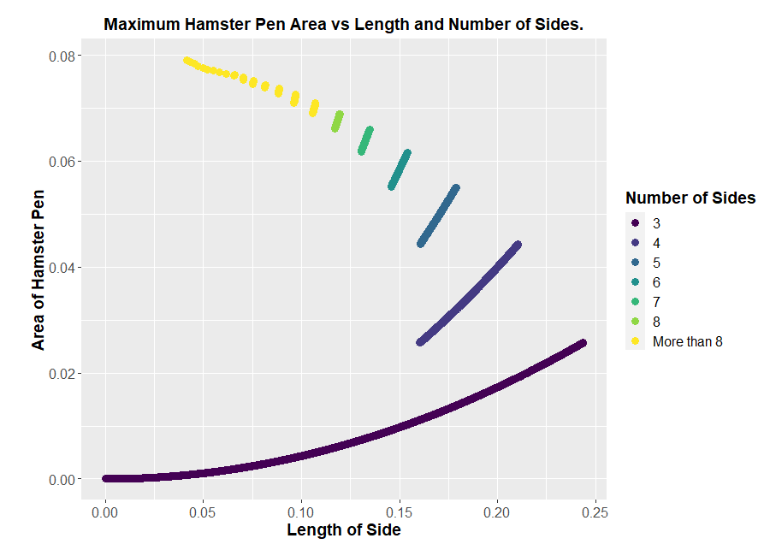

Rohan Lewis

2020.08.24